June 7, 2014 ESWA Workshop Joan D. Cooper jtomfoolery@aol.com
joandcooper.com
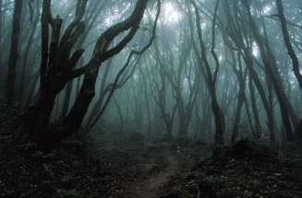
Setting as the Genesis of Motif
- Introductions with postcards

- Setting—Definition and beyond
  - Location
  - Time
  - Beyond time and place—
      - The physical place inhabited by the speaker
      - The touchstones of similar experience for the reader
      - Specific versus the universal
      - Gray screen versus cushion

- Examples in Literature—
  - Natural Elements
  - Concrete Objects
  - Events
  - Places

- Exercise 1 -- Postcards
  - Step 1--List the details of the scene from the postcard
  - Step 2—Squeeze out detail
  - Analyze the scene

- Developing the setting beyond backdrop
  - Settings that become symbolic--
  - Warning against assumption
  - Examples of personal landscapes in literature
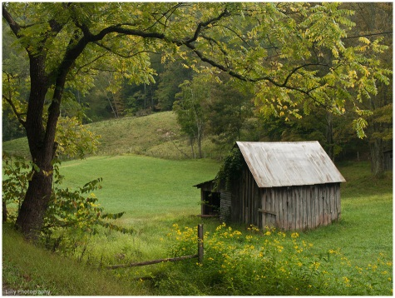
- Setting Exercise 2 for your story or memory
  - Visualization
  - 20 Questions
  - Research, reality and fiction

- Mapping the setting--know the logistics of your story
  - Landscape and time that can be traversed
  - Use anchors in the landscape
  - Published works

- Exercise 3--Setting Map--Choose one setting for a novel, a short story or a memoir.
  - Jot ideas for the landscape and the time period in a thumbnail
  - Draw a map of the place
      - Name the streets, avenues, paths and houses
      - Add details that give away the time period
      - Choose the focal point and give it a color
      - Trace the path of the main character through this landscape either in a scene or the whole story

- Motifs developed through setting
  - Definition and history
  - Standard literary examples
  - Examples
    - Natural Elements
    - Concrete Objects
    - Events
    - Places

- Group String Exercise 4
  - Using nature—describe a storm as destructive but energizing
  - Using concrete objects—describe something red to signal change or tonal shift
  - Using place—describe a door that forbids entrance and distresses
  - Using time—describe a summer evening that refreshes and calms
  - Individual String Exercise 5--written work and map

- Summary and Reflection

The Last Things I'll Remember
by Joyce Sutphen
The partly open hay barn door, white frame around the darkness,
the broken board, small enough for a child
to slip through.
Walking in the cornfields in late July, green tassels overhead,
the slap of flat leaves as we pass, silent
and invisible from any road.
Hollyhocks leaning against the stucco house, peonies heavy
as fruit, drooping their deep heads
on the dog house roof.
Lilac bushes between the lawn and the woods,
a tractor shifting from one gear into
the next, the throttle opened,
the smell of cut hay, rain coming across the river,
the drone of the hammer mill,
milk machines at dawn.
"The Last Things I'll Remember" by Joyce Sutphen from First Words. © Red Dragonfly Press, 2010.

Sins of the Fathers
by Mark Vinz
My daughter wants the car tonight, no,
needs the car tonight—to go somewhere,
to do some things, you know, be back
before it gets too late, of course,
if I say so, which I always do,
of course. I trust her—it's the others
I don't trust, the others I worry about,
and round we go again.
Headlights pass the driveway—
I study every shadow on the wall,
each voice from the dark street,
and laughter—faint, familiar
laughter, rising and falling
on every breath of wind.
"Sins of the Fathers" by Mark Vinz from Mixed Blessings. © Spoon River Poetry Press, 1989.

